

Arab American University

Faculty of Engineering and Information Technology

MICROPROCESSER LAB

Prepared by:

Suha Waleed Alardah 201811033

Naema Bsharat 2018

To:Dr.Mahmoud obaid

To:Mrs.Noor Kmail

Introduction :

The LED DOT MATRIX IS INTERFACEED TO THE 82C55 DEVICE LABELED U3.

THE DOT MATRIX HAS 8X8 DOTS EVERY DOT HAS 2 DIODES

EVERY ROWS IS COMON ANODE

THAT’S MEAN :

0: OFF

1:  ON

AND THE COULOMN IS COMON CATHOD

THAT’S MEAN :

0: ON

1:  OFF

IT HAS THREE COLOURS : RED , GREEN AND ORANGE ,

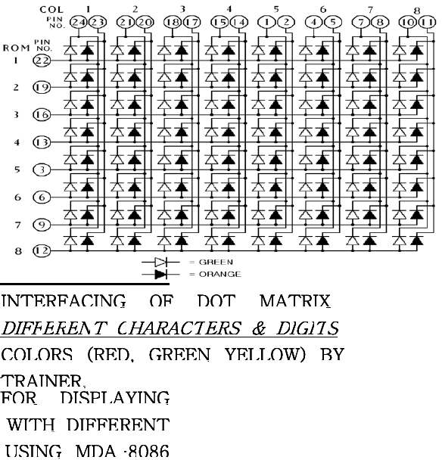

*TASK1:*

WRITE A CODE THAT TURN THE CELL FOLLOWS

|  |  |  |  |  |  |  |  |
| --- | --- | --- | --- | --- | --- | --- | --- |
|  |  |  |  |  |  |  |  |
|  |  |  |  |  |  |  |  |
|  |  |  |  |  |  |  |  |
|  |  |  |  |  |  |  |  |
|  |  |  |  |  |  |  |  |
|  |  |  |  |  |  |  |  |
|  |  |  |  |  |  |  |  |
|  |  |  |  |  |  |  |  |

CODE SEGMENT

ASSUME CS:CODE, DS: CODE, ES:CODE, SS:CODE

PPICC EQU IEH

PPIC EQU 1CH

PPIB EQU 1AH

PPIA EQU 18H

ORG 1000H

MOV AL, 80H

OUT PPICC AL

MOV AL, OFFH

OUT PPIC, AL

MOV AL, OFFH

OUT PPIB, AL

MOV AL, 2AH

OUT PPIC, AL

MOV AL, OABH

OUT PPIA, AL

CALL TIMER

INT 3

TIMER: MOV CX, 0FFFFH

TIMERI: NOP

NOP

NOP

NOP

LOOP TIMERI

RET

CODE ENDS

END

TASK2: WRITE ASSEMPLY CODE THAT DOING FOLLOW MAKE A ROW ONE IS ON

CODE SEGMENT

ASSUME CS:CODE, DS: CODE, ES:CODE, SS:CODE

PPICC EQU IEH

PPIC EQU 1CH

PPIB EQU 1AH

PPIA EQU 18H

ORG 1000H

MOV AL, 80H

OUT PPICC, AL

MOV AL، 00H

OUT PPIA، AL

MOV AL، OFFH

OUT PPIB، AL

L1: MOV AL، 01H

OUT PPIC، AL

CALL TIMER

STC

ROL AL، 1

JNC L2

JMP LI

INT 3

TIMER: MOV CX، 0FFEEH

TIMER1: NOP

NOP

NOP

NOP

LOOP TIMER1

RET

CODE ENDS

END

TASK3:MODIFY THE TASK2 TO MOVE ALL ROWS

CODE SEGMENT

A ASSUME CS:CODE, DS:CODE, ES:CODE, SS:CODE

PPICC EQU IEH

PPIC EQU 1CH

PPIB EQU 1AH

PPIA EQU 18H

ORG 1000H

MOV AL, 80H

OUT PPICC ,AL

MOV AL, OFFH

OUT PPIB, AL

MOV CX, 4

NEW:

MOV AL,91H

OUT PPIC,AL

MOV AL, 66H

OUT PPIA, AL

CALL TIMER

MOV AL 00H

OUT PPIC,AL

MOV AL, 0FFH

OUT PPIA, AL

CALL TIMER

LOOP NEW

INT 3

TIMER: MOV CX, OFFFFH

TIMER1: NOP

NOP

NOP

NOP

LOOP TIMER1

RET

CODE ENDS

END

## TASK4:WRITE ASSEMBLY CODE THAT SHOWS THE FOLLOWING SHAP

|  |  |  |  |  |  |  |  |
| --- | --- | --- | --- | --- | --- | --- | --- |
|  |  |  |  |  |  |  |  |
|  |  |  |  |  |  |  |  |
|  |  |  |  |  |  |  |  |
|  |  |  |  |  |  |  |  |
|  |  |  |  |  |  |  |  |
|  |  |  |  |  |  |  |  |
|  |  |  |  |  |  |  |  |
|  |  |  |  |  |  |  |  |

*TASK5:MODIFY THE TASK 4 TO MOVE THE CORNER POINT DIGONAL MOMENTS*

*Conclusions:*

IN THIS EXPEREMENT WE NOTICE THAT PORTA DRIVES THE GREEN LEDs WHILE PORTB DRIVES THE RED LEDs .PRTA AND B SELECT THE COLUMNS .WHILE PORTC SELECT THE ROWS

WE FIND DIFICELT TO TURN ON THE LED IN DIAGONAL AND FINALLY CHOICE DEFINE BYTE OF EVERY CELL.